**Assignment 1**-

Full_name --- First_name and Last_name

Salary --- Basic_Salary

HRA –10%

DA – 5%

PF – 7%

GrossSalary – Salary +HRA + DA – PF

select first_name,last_name,**concat**(first_name,last_name)as Full_name, salary,salary*.10 HRA ,salary*.5 DA, salary*.7 PF,**concat**(salary+salary*.10+salary*.5-salary*.7) as Gross_Salary from employees;

select first_name,last_name,concat(first_name,last_name)as Full_name, salary,salary*.10 HRA ,salary*.5 DA, round(salary*.7,2)as PF ,concat(salary+salary*.10+salary*.5-salary*.7) as Gross_Salary from employees;

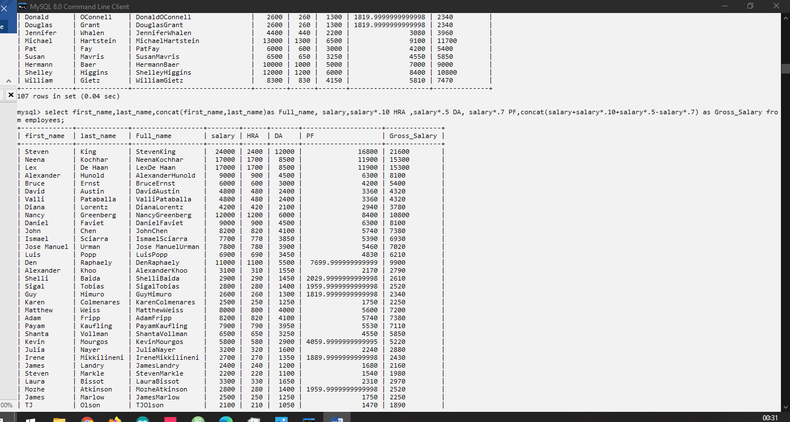

select * from employees where salary >10000;

select first_name,hire_date from employees where job_id ='IT_PROG' or job_id='SA_MAN';

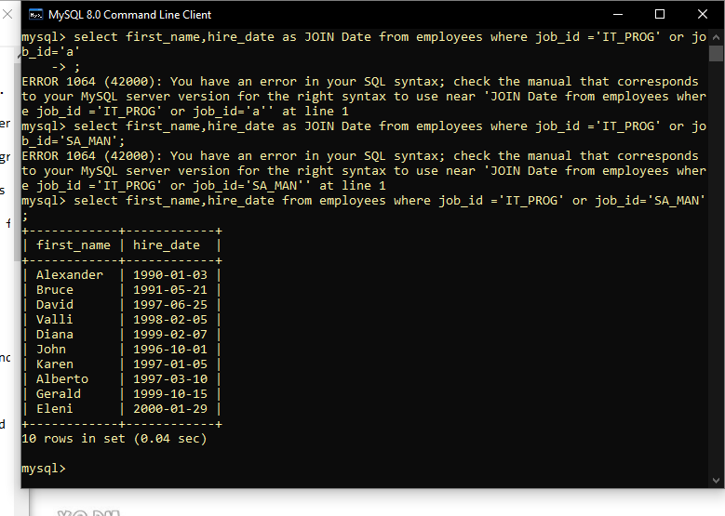

select first_name ,salary,commission_pct,hire_date from employees where salary < 10000;

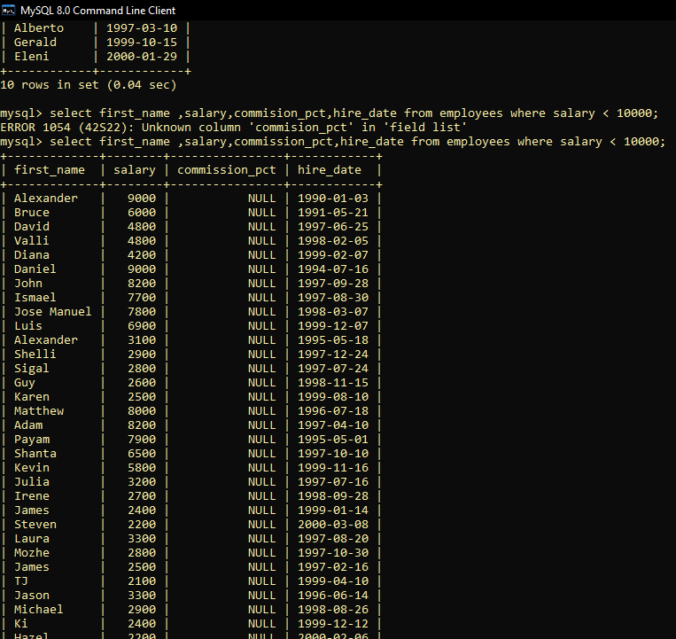

select * from employees where salary between 10000 and 20000 order by salary desc;

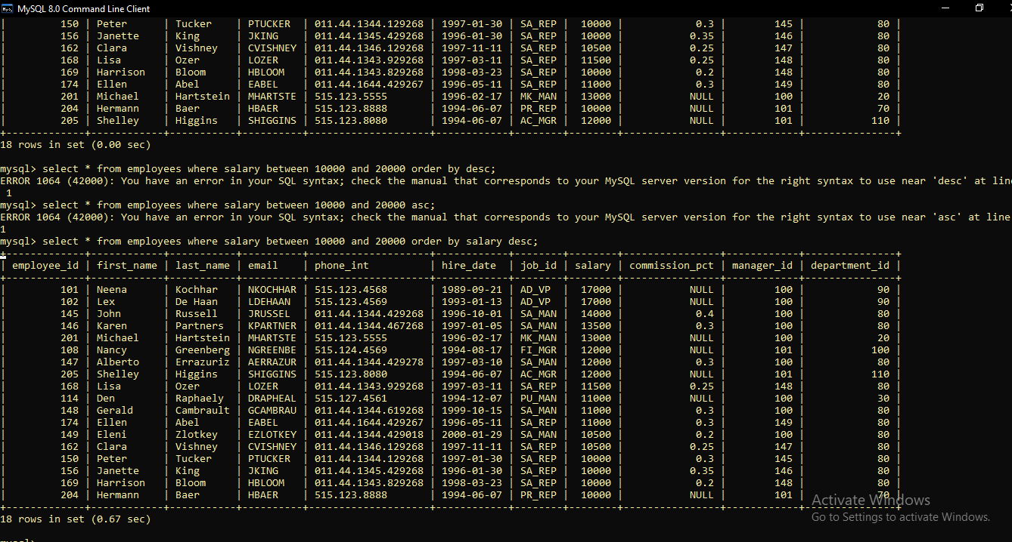

select * from employees where first_name or last_name like 'S%';

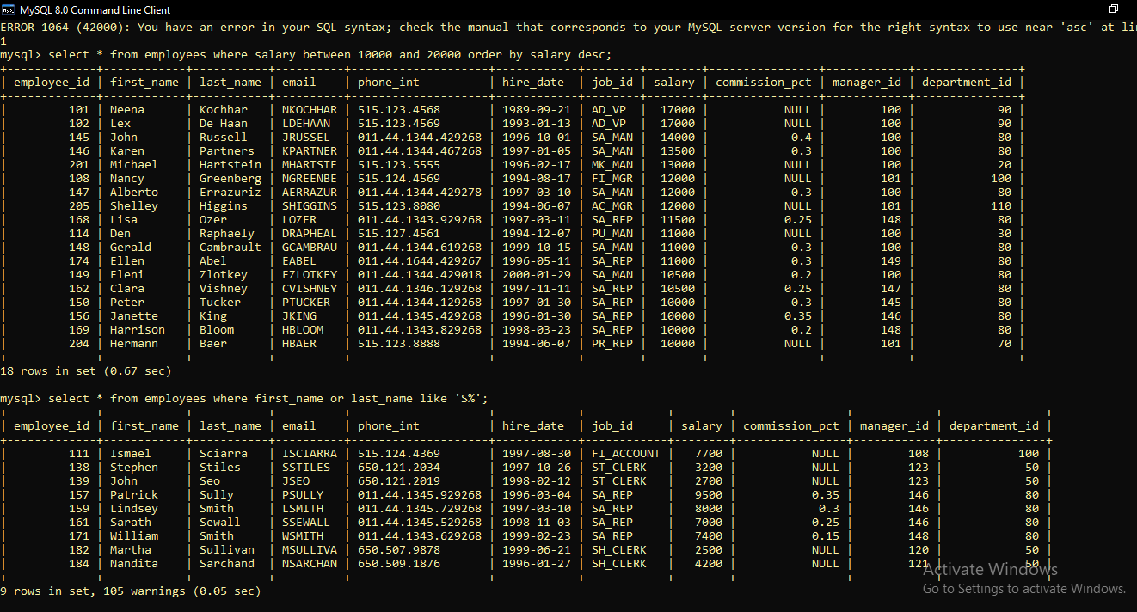

select job_id from employees order by job_id desc;

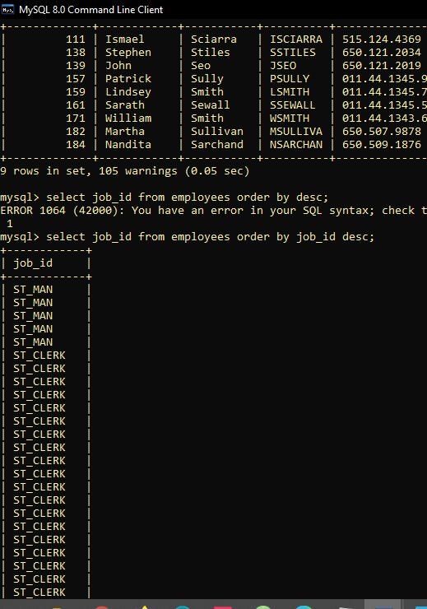

select employee_id, first_name,last_name,hire_date from employees where hire_date like '____-%05%-__';

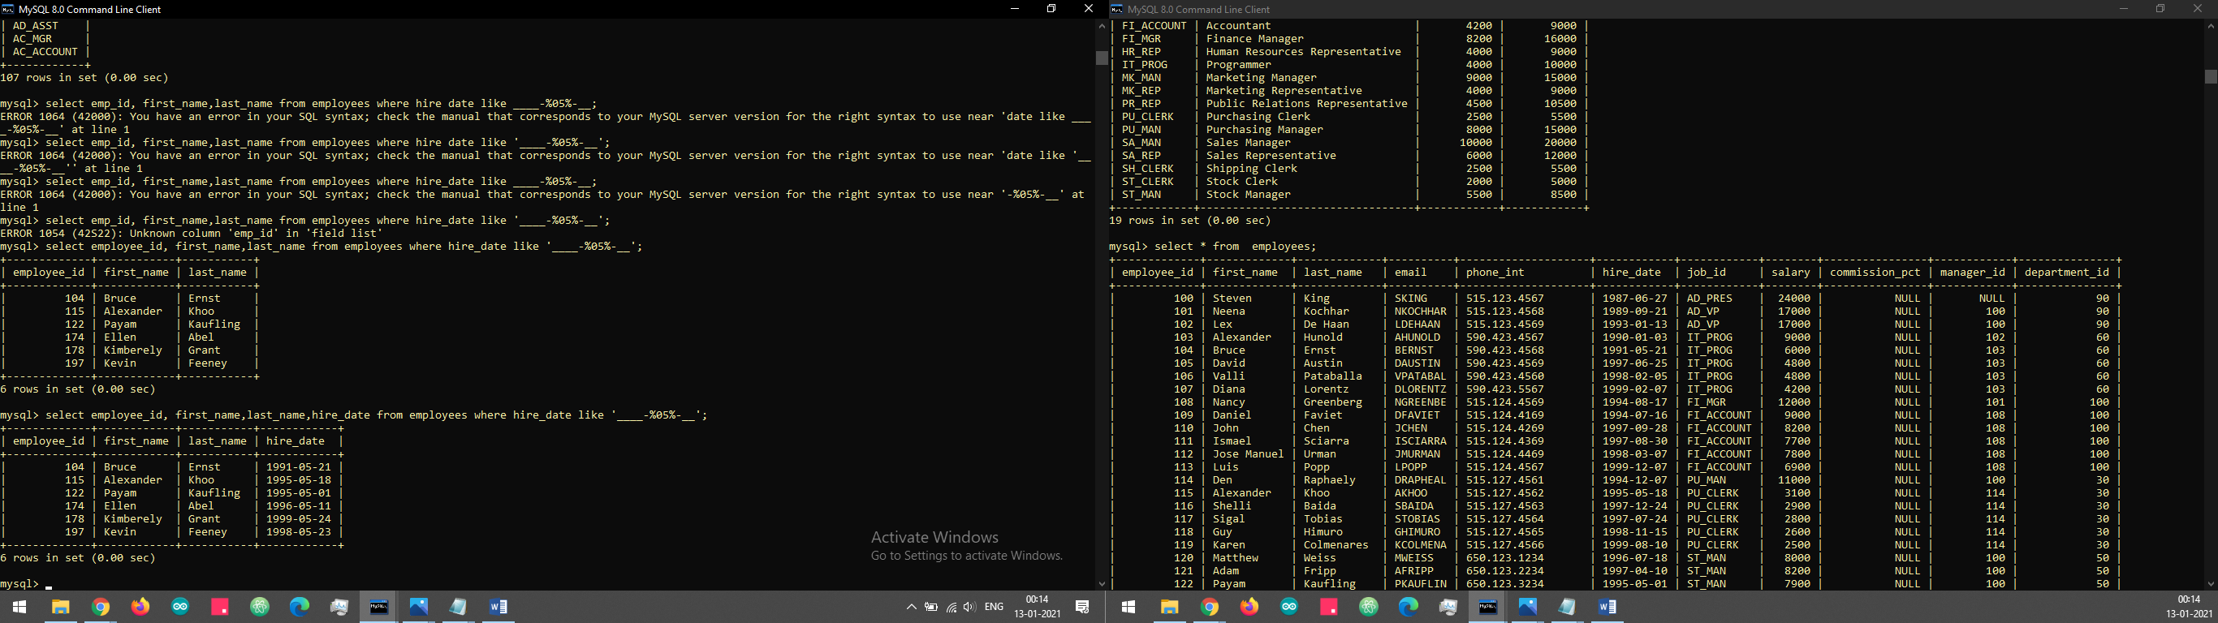

Display details of the employees where commission percentage is null and salary in the range 5000 to 10000 and department is 30.

select * from employees where commission_pct=null and salary between 5000 and 15000 and department_id=30 ;